STANDARD OPERATING PROCEDURE
Order Return & Refund Processing
Inspection, Eligibility Review, Refund & Resolution

Document No. | SOP-VA-RET-001
Version | 1.0
Effective Date | Demo build — July 2026
Company | Bloom & Basket Co. (fictional)
Prepared By | Michael Abat, Operations & Process VA
Reviewed By | [Self-reviewed — demo project]
Approved By | [Fictional Client — not applicable]
Next Review | 12 months from effective date

DEMO COPY ONLY — SELF-INITIATED DEMONSTRATION PROJECT. Bloom & Basket Co. is a fictional company created to show a realistic order return and refund process. No real client, data, or business is involved.

1. Purpose
This Standard Operating Procedure (SOP) defines the process for handling customer order returns and refunds at Bloom & Basket Co. It applies to a small e-commerce operation seeking a consistent, well-documented returns process.
The procedure ensures that:
- Every returned item is inspected and logged the same way.
- Two built-in quality checkpoints catch mismatched or incorrect refunds before processing.
- Each return is tracked from receipt to resolution.
2. Scope
This SOP applies to:
- Fulfillment Associates who receive and inspect returned items.
- Returns Specialists who review eligibility, process refunds, and close the return.
This SOP does not cover:
- Warranty claims for manufacturer defects (separate process).
- Exchanges for a different size or color (separate process).
3. Roles & Responsibilities
Role | Responsibility
Fulfillment Associate | Receives returned items, inspects condition, and logs details in the tracker.
Returns Specialist | Reviews return eligibility, verifies refund amounts, and processes resolution.

4. Process Flow
The diagram below shows the full returns process across both roles, including the two quality checkpoints.
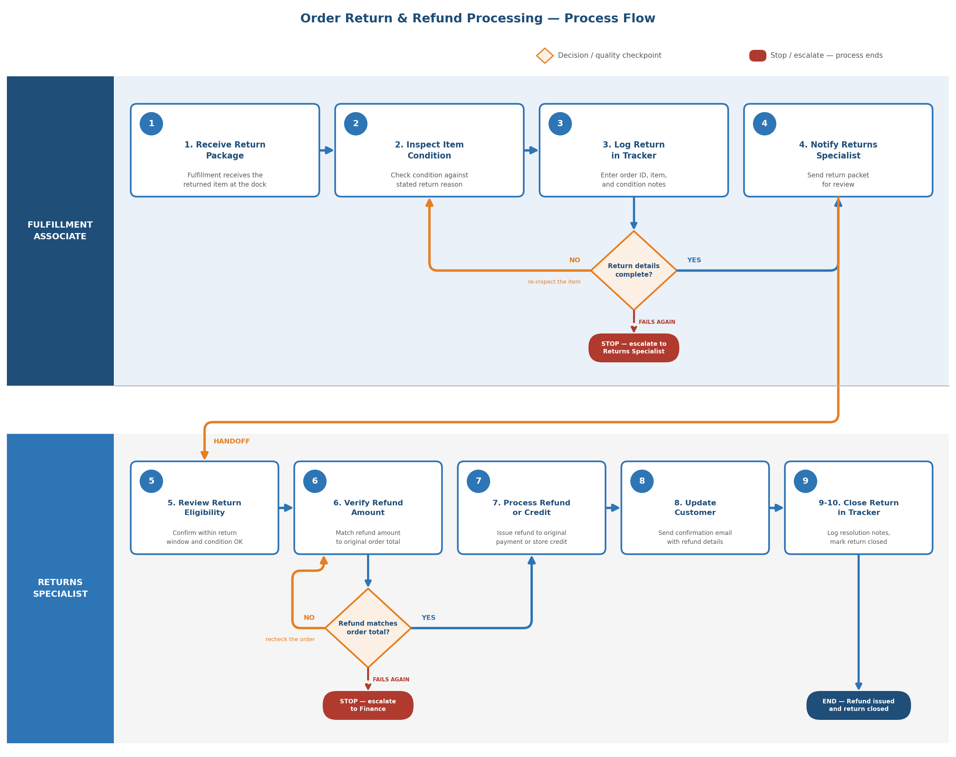

5. Procedure
5.1 Return Receipt & Inspection (Fulfillment Associate)
- Receive the returned package at the dock.
- Inspect the item condition against the customer's stated return reason.
- Log the order ID, item, and condition notes in the returns tracker. (Quality Checkpoint 1) If the return details are incomplete, re-inspect the item and log it again. If they are still incomplete on the second check, stop and escalate to the Returns Specialist.
- Notify the Returns Specialist and forward the return packet.
5.2 Eligibility Review & Resolution (Returns Specialist)
- Review the return against the eligibility window and condition policy.
- Verify the refund amount matches the original order total. (Quality Checkpoint 2) If the amount does not match, recheck the original order before processing. If it still does not match, stop and escalate to Finance.
- Process the refund to the original payment method or issue store credit.
- Send the customer a confirmation email with the refund details.
- Log the resolution notes and mark the return as closed in the tracker.
6. Common Errors & Prevention
Common Error | Prevention
Refund amount does not match order total | Verify refund against the original order total before processing — mandatory checkpoint.
Return accepted outside the eligibility window | Tracker flags return date against the policy window automatically.
Customer not notified of refund status | Confirmation email is a required step before the return can be closed.
7. Revision History
Version | Date | Description | Author
1.0 | July 2026 | Initial demo release | Michael Abat

