STANDARD OPERATING PROCEDURE
Machine Downtime & Maintenance Reporting
Reporting, Diagnosis, Repair & Resolution

Document No. | SOP-VA-MNT-001
Version | 1.0
Effective Date | Demo build — July 2026
Company | Ironclad Metal Works (fictional)
Prepared By | Michael Abat, Operations & Process VA
Reviewed By | [Self-reviewed — demo project]
Approved By | [Fictional Client — not applicable]
Next Review | 12 months from effective date

DEMO COPY ONLY — SELF-INITIATED DEMONSTRATION PROJECT. Ironclad Metal Works is a fictional company created to show a realistic machine downtime reporting process. No real client, data, or business is involved.

1. Purpose
This Standard Operating Procedure (SOP) defines the process for reporting, diagnosing, and resolving machine downtime at Ironclad Metal Works. It applies to a small metal fabrication operation seeking faster downtime response and cleaner maintenance records.
The procedure ensures that:
- Every downtime event is reported and logged the same way.
- Two built-in quality checkpoints confirm the fault is understood before repair and confirmed fixed before clearing.
- Each downtime event is tracked from report to resolution for root cause trending.
2. Scope
This SOP applies to:
- All machine operators on the production floor who encounter equipment faults or stoppages.
- Maintenance Technicians responsible for diagnosis, repair, and machine clearance.
This SOP does not cover:
- Scheduled preventive maintenance (separate process).
- Capital equipment replacement or engineering change requests.
3. Roles & Responsibilities
Role | Responsibility
Machine Operator | Detects and reports faults, stops the machine safely, and logs downtime start time.
Maintenance Technician | Reviews fault reports, diagnoses root cause, performs repairs, and clears the machine for use.

4. Process Flow
The diagram below shows the full downtime process across both roles, including the two quality checkpoints.
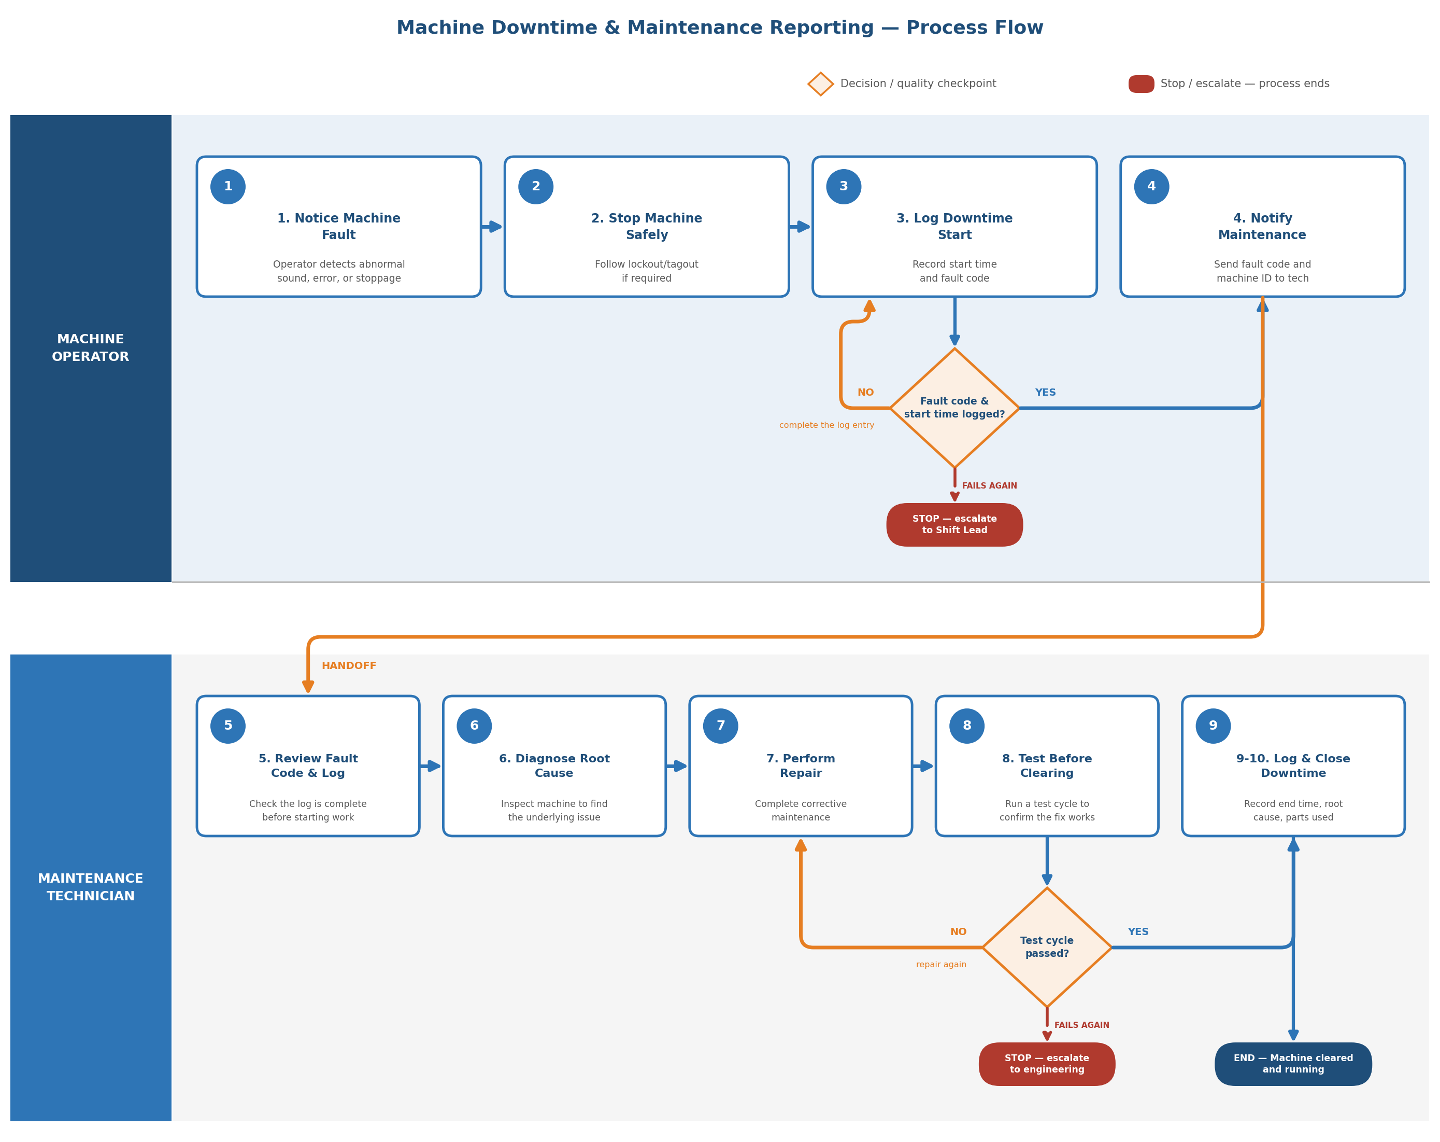

5. Procedure
5.1 Downtime Reporting (Machine Operator)
- Notice the machine fault — abnormal sound, error code, or full stoppage.
- Stop the machine safely, following lockout/tagout procedure if required.
- Log the downtime start time and fault code in the maintenance tracker. (Quality Checkpoint 1) Confirm the fault code against the standard fault code list before notifying maintenance. If the code or start time is missing, complete the log entry. If it is still incomplete on the second check, stop and escalate to the Shift Lead.
- Notify the Maintenance Technician with the machine ID and fault code.
5.2 Diagnosis & Repair (Maintenance Technician)
- Review the fault code and downtime log, then plan the repair.
- Diagnose the root cause through inspection and testing.
- Perform the corrective repair or part replacement.
- Run a test cycle to confirm the fix works before clearing the machine. (Quality Checkpoint 2) If the test cycle fails, repeat the repair. If it fails a second time, stop and escalate to engineering — do not clear the machine.
- Log the downtime end time, root cause, and parts used in the tracker.
- Confirm with the Operator that the machine is cleared to resume production.
6. Common Errors & Prevention
Common Error | Prevention
Fault code missing or unclear at handoff | Use a standard fault code list; operator confirms code before notifying maintenance.
Machine cleared without a test run | Test cycle is a mandatory checkpoint before the tracker allows claim closure.
Root cause not recorded | Tracker requires a root cause entry before a downtime record can be closed.
7. Revision History
Version | Date | Description | Author
1.0 | July 2026 | Initial demo release | Michael Abat

